EHI 2016 media release

New EU heart study:
UK lags behind in heart care
Major inequalities in the use of basic heart medicines between countries
Still after almost 70 years of NHS, British heart care, ranking 15th among 30 measured countries, cannot really compete with the best continental health systems, says the Euro Heart Index 2016 (EHI), published today in Brussels. The Index compares heart care in 30 European countries, with France the champion, closely followed by Norway and Sweden. Heart care improves in almost every country but the gaps across Europe threaten equity. Equal access to basic heart medication would save tens of thousands of lives.
“Popular prevention efforts in the UK are still hampered by bad life style: too much alcohol and sugar and too little vegetables and fruits” says Dr. Beatriz Cebolla, the EHI Director. "For decades, heart care has been a prominent part of the NHS. Still the analysis shows only mediocre but improving performance, with regular audits that would help to understand where to focus. Waiting times, a chronic condition in the UK, have improved but still lag behind most comparable continental countries.”
Professor Arne Björnberg, the HCP Chairman, explains the larger picture: “In heart care, there is a remarkable lack of a joint pan-European standard how to treat patients. The deployment of basic heart medicines seem haphazard, hardly reflecting the needs of Europeans. More consistent use of inexpensive generic drug therapies such as statins and clopidogrel would save thousands of lives!"
“Evidently, there is a connection between high spending and good outcomes. Affluent countries can afford admitting patients into hospital care on weaker indications, which can prevent that conditions grow worse”, adds Professor Björnberg. “But a lot can be achieved also with small budgets, with the right priorities.”
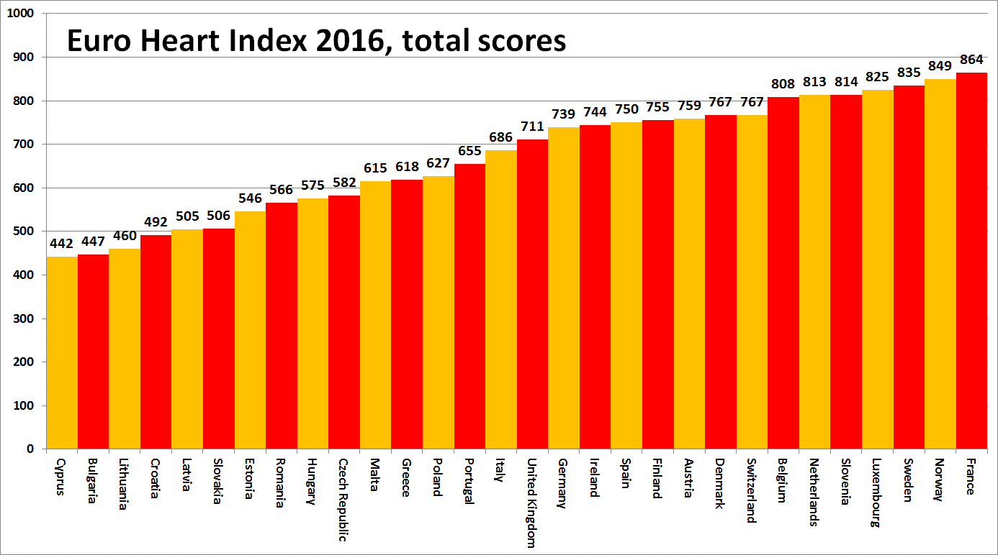
About the EHI
The Euro Heart Index provides a ranking of cardiovascular healthcare systems in 30 countries across four key areas: Prevention, Procedures, Access to care and Outcomes, measured on 31 indicators. The Index is constructed from public statistics and independent research. The producer of the EHI is the Health Consumer Powerhouse Ltd, which has been analysing performance of European national healthcare systems in around 50 index publications since 2004. All HCP indexes take a consumer-centric position. The production of the EHI 2016 was supported by an unrestricted grant from Amgen Europe GmbH.
Full EHI report with data and methodology explained, matrix and media releases are freely available on: www.healthpowerhouse.com/publications/euro-heart-index-2016/
For further information, please contact:
EHI project director: Dr. Beatriz Cebolla (beatriz.cebolla@healthpowerhouse.com),
+49 152 2371 9856
HCP Ltd chairman: Professor Arne Bjornberg (arne.bjornberg@healthpowerhouse.com),
+46 705 848451

(c) HCP Ltd. 2016

