What the annual EU healthcare review reveals:
Copying the most successful health systems would save European lives and money
(Stockholm, January 30, 2017) European healthcare is steadily improving: infant mortality as well as survival rates of heart disease, stroke and cancer are all moving in the right direction. Patient choice and involvement are developing. But still too many countries stick to inefficient ways to fund and deliver care services. Copying the most successful European healthcare systems would save money to be invested in saving lives and improving performance among the many countries struggling to meet citizens’ expectations. This is a main conclusion from the 2016 Euro Health Consumer Index (EHCI), published today by the Health Consumer Powerhouse (HCP) Ltd.
The EHCI, started in 2005, is the leading comparison for assessing the performance of national healthcare systems in 35 countries. The EHCI analyses national healthcare on 48 indicators, looking into areas such as Patient Rights and Information, Access to Care, Treatment Outcomes, Range and Reach of Services, Prevention and use of Pharmaceuticals. The new Index ranks the countries (minimum score is 333, the maximum 1000):
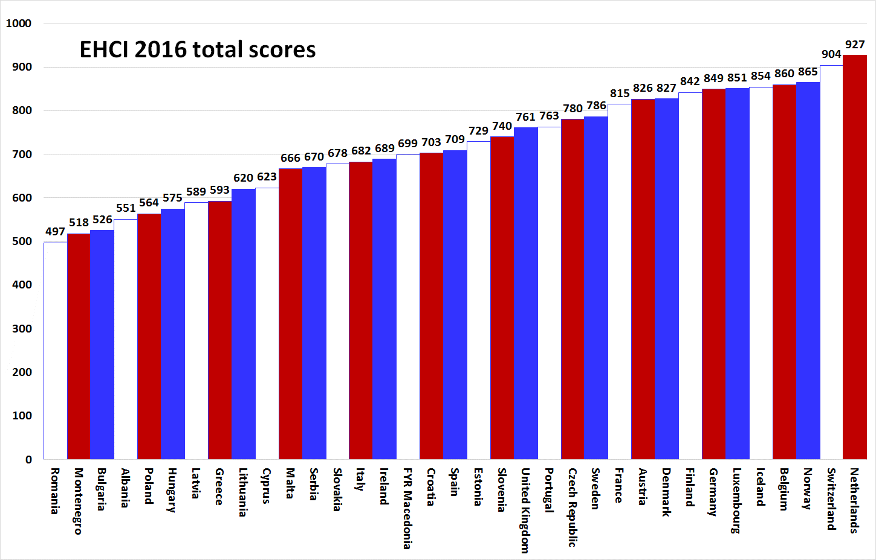
For the first time two countries – the Netherlands (927) and Switzerland (904) – break the 900 points barrier in the EHCI. This means that they are coming close to meeting all the criteria for good, consumer-friendly healthcare formulated by the Index since 2005. A notch behind are Norway (865), Belgium (860), Iceland (854), Luxembourg (851), Germany (849) and Finland (842). In spite of a general improvement among all national health systems the gap remains between the top performers (in Northwestern Europe plus Switzerland) and the least developed ones (in former CEE and Southeastern Europe).
Among the winners of the six sub-disciplines Patient rights and information, Accessibility/Waiting, Treatment outcomes. Range and reach of services, Prevention and Pharmaceuticals are established national systems with good funding and traditions.
Norway reaches a full score on Patient rights. The same goes for Belgium, Macedonia and Switzerland on Accessibility. Sweden and the Netherlands gain maximum score on Range and reach of services.
The only exception from the above pattern is FYR Macedonia, the small Balkan country taking a radical twist on access by jumping from nothing to a highly transparent application for electronic booking of care appointments. This has more or less eliminated waiting times in healthcare.
Sub-discipline | Top country/countries | Score | Maximum score
1. Patient rights and information | Norway | 125! | 125
2. Accessibility | Belgium, FYR Macedonia, Switzerland | 225! | 225
3. Outcomes | Finland, Iceland, Germany, Netherlands, Norway, Switzerland | 288 | 300
4. Range and reach of services | Netherlands, Sweden | 125! | 125
5. Prevention | Norway | 119 | 125
6. Pharmaceuticals | France, Germany, Ireland, Netherlands, Switzerland | 86 | 100

- FYR Macedonia shows what can be achieved by imagination, determination and firm leadership, says Professor Arne Bjornberg, head of the EHCI research. This being possible in a not-too-wealthy country challenges many conventional attitudes in healthcare. Even if the EHCI shows steady progress in European healthcare, much more needs to be done. If governments stop trying to re-invent the wheel in favour of copying proven progress, health reform speed could increase. That would reduce mortality, improve quality of life and save money!
The EHCI ranking of cost-efficient healthcare ("Bang for the Buck") shows the relation between money spent on public healthcare and the performance of healthcare systems. Some countries provide very good healthcare in relation to the cost. Since the EHCI started, Estonia and the Czech Republic has offered good value for money and lately Finland and Portugal have joined this group. These countries has a story to tell how to deliver affordable care. Such success is free to copy!
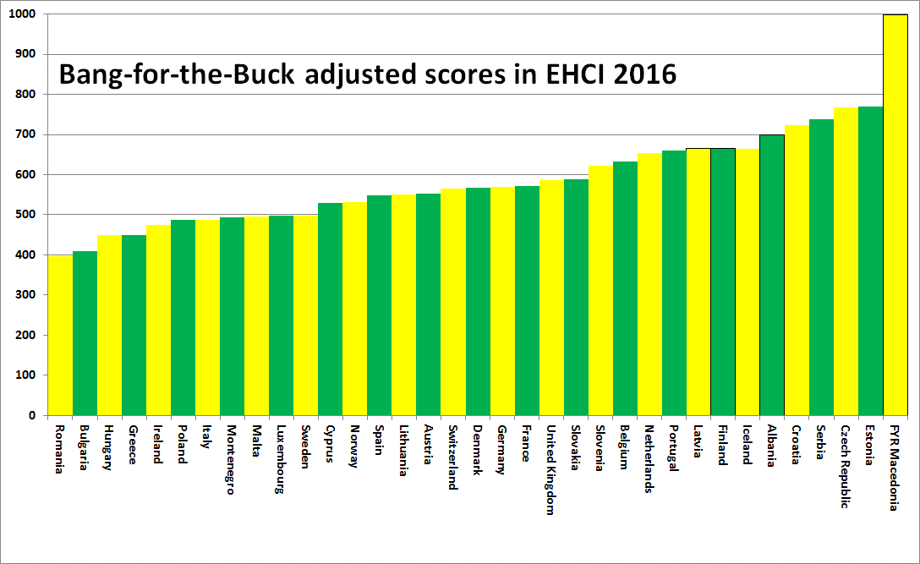
- In the other end of the rank are found countries that pay far too much for healthcare, given the poor performance, explains Professor Bjornberg. Romania and Bulgaria have a tradition of long hospital stays which they cannot afford. Poland and Hungary try to deny the need for radical health systems reform. And Ireland sticks to inefficient, unequal semi-private funding, to pick a few examples.
But also among countries above the EHCI average there are major reform needs, such as:
- What would it mean to shorter waiting, cost of queuing and personal inconvenience if many more countries offered the same prompt access to care as Belgium (and Macedonia)?
- With prevention still an underutilized resource for better health, imagine what can be achieved if Norway, the leader in this EHCI sub-discipline, would set the standard to be copied and implemented around Europe?
- When Lithuania and Romania has introduced e-Prescriptions, what hinders the 16 countries still caught in old paper-based systems to jump into the era of patient-friendliness? Vested interests? Lack of determination? Idleness?
- As a growing number of European health systems start approaching the maximum EHCI score there will be a need to re-design the Index during 2017. Also the complexity of patient-centered healthcare challenges assessment methods, says Johan Hjertqvist, HCP founder and president.
The full EHCI 2016 report and index matrix are available on: http://www.healthpowerhouse.com/publications/euro-health-consumer-index-2016/
For further information, please contact:
arne.bjornberg@healthpowerhouse.com or mobile: +46 70 584 8451
johan.hjertqvist@healthpowerhouse.com or mobile: +46 70 752 1899

