Euro Health Consumer Index 2014:
In spite of shorter waiting and fewer killer bugs, NHS England and Scotland still have a long way to top healthcare ranking

(Brussels, January 27, 2015)
England ranks 14th in the 2014 Euro Health Consumer Index, scoring 718 points out of the maximum 1000, one position down since the 2013 study.
The 8th edition of the EHCI was presented today in Brussels in the presence of the EU Health Commissioner Vytenis Andriukaitis. The Netherlands stay on top, gaining 898 out of maximum 1 000 points, followed by Switzerland, Norway, Finland and Denmark. The study includes 36 countries plus Scotland. NHS England and NHS Scotland are compared, with Scotland coming out 16th at 710 points.
- In spite of slightly reduced spending on healthcare in many countries, overall healthcare performance keeps improving, explains Dr. Arne Bjornberg, HCP chairman and head of research. The initial measurement 2006 awarded just one country with more than 800 out of maximum 1000 points. 2014 there are no less than nine such high-performing healthcare systems!
Among the 48 indicators in the study, only eleven separate the two NHS systems. Anyhow, certain characteristics emerge as this comparison is done for the second time in a row. NHS England offers better patient information while in Scotland, waiting is generally shorter. Treatment outcomes are equal, but with poor Scottish performance on Depression. England is somewhat more generous with regard to the span of offered services (interesting as the Scottish system is overall ten percent more expensive). Prevention works a little better in England (in spite of joint problems with high alcohol consumption and failing vaccination for children) while pharmaceuticals are as accessible in both systems.
Recommendations for English/Scottish improvement
- The EHCI patient organisation survey confirms the claims from the English NHS that the very large resources invested in reducing waiting list problems healthcare have paid off, which is the case with Scotland as well. But the U.K. is still definitely a part of European “waiting list territory”, warns Dr. Bjornberg. Unfortunately, in 2014 the English Waiting Time scores are worsening slightly, which is confirmed by English press reports on healthcare accessibility.
- The efforts to clean up hospitals to reduce resistant hospital infections have also paid off: both England and Scotland score Amber on this indicator. This radical reduction is a unique performance for a European country and should continue. For both England and Scotland, the poor access to new cancer drugs should be improved.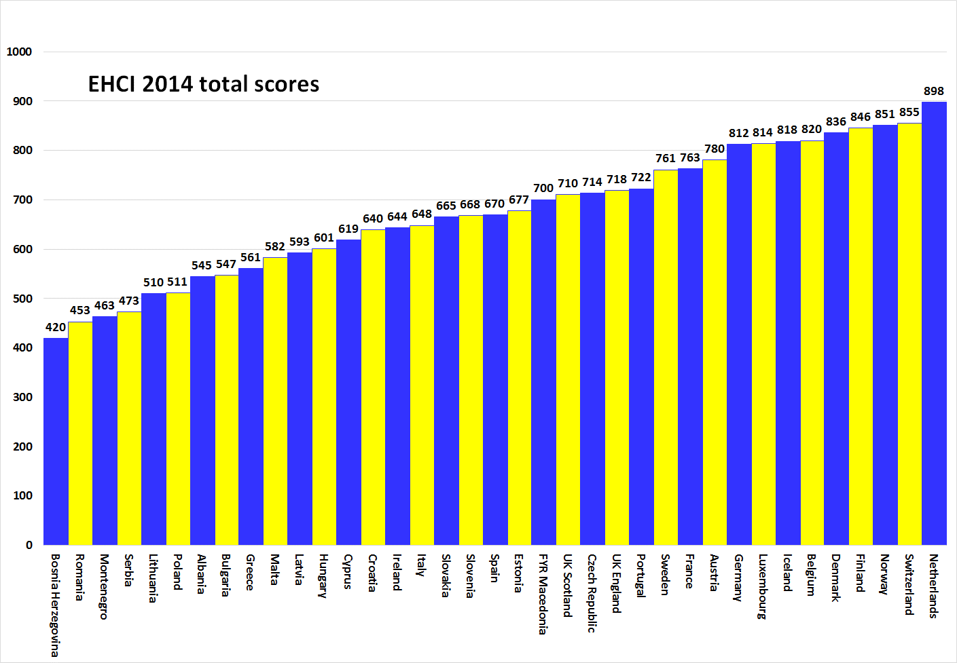

About HCP
The EHCI has become an “industry standard” of modern healthcare monitoring since the start in 2005. The Index is compiled from a combination of public statistics, patient polls and independent research conducted by Health Consumer Powerhouse Ltd, a Sweden-based private company, measuring the performance of healthcare in Europe and Canada to support patient and consumer empowerment. As the European Commission now will systematically engage in the assessment of member state health systems, EHCI sets an example.
The EHCI 2014 has been supported by unrestricted grants from Medicover S.A., Belgium, and New Direction Foundation, Belgium.
The EHCI material is published on the HCP website: www.healthpowerhouse.com . It is freely available and anybody is welcome to quote it, referring to the source.
For questions and information:
Arne Bjornberg: +46 70 584 84 51; arne.bjornberg@healthpowerhouse.com
Johan Hjertqvist: +46 70 752 18 99; johan.hjertqvist@healthpowerhouse.com

“We know the Euro Health Consumer Index (EHCI) is today the leading public measurement of how national healthcare systems perform ...We have recently learned that the European Commission after assessing various benchmarks has found the EHCI to be the most accurate and reliable comparison".
Dr. Vytenis Andriukaitis, Lithuania's Minister of Health, 2013 (since November 2014 the EU Commissioner of Health and Consumer Protection)
© HPC Ltd. 2015

