Euro Health Consumer Index 2014:
Many years of patient criticism sends Irish healthcare deep down in EU ranking, behind Italy and Slovakia

(Brussels, January 27, 2015)
Ireland ranks 22nd in the 2014 Euro Health Consumer Index, scoring 644 points out of the maximum 1000, a deep dive from the 14th position in the 2013 study.
The 8th edition of the EHCI was presented today in Brussels in the presence of the EU Health Commissioner Vytenis Andriukaitis. The Netherlands stay on top, gaining 898 out of maximum 1 000 points, followed by Switzerland, Norway, Finland and Denmark. The study includes 36 countries plus Scotland.
- In spite of slightly reduced spending on healthcare in many countries, overall healthcare performance keeps improving, explains Dr. Arne Bjornberg, HCP chairman and head of research. The initial measurement 2006 awarded just one country with more than 800 out of maximum 1000 points. 2014 there are no less than nine such high-performing healthcare systems!
Irelands takes a sharp dive in the 2014 EHCI, falling in the ranking as well as in achieved index points. Few countries suffer a reduction of awarded points but in 2014 Ireland gets only 644 points, 46 less than 2013. What explains this dramatic outcome?
- For several years, Irish patient organisations have been most pessimistic in their responses to the patient survey conducted as part of EHCI research. This has happened also in other countries, but then patients, with a slight time lag, have gradually become less negative. After six years of persistent patient criticism the official waiting list data have lost credibility. As a matter of principle, in the EHCI 2014 it was decided to use the patient organisation feedback to score Ireland on waiting times. This accounts for the drop from rank 14 to 22, explains Dr Bjornberg.
Recommendations for Irish improvement
- Ireland is a strange artefact among the healthcare systems of North-Western Europe, comments Dr. Bjornberg. Patient empowerment is on the level of Romania, waiting times as long as in Sweden (which is Bad!) and healthcare inequity is evident. Wide-spread duplicate healthcare insurance can be interpreted as an extreme case of dissatisfaction with the public system. Ireland should take radical action to improve patient information and empowerment and reduce waiting to the level of other EU members.
- Ireland has no longer a total ban on abortion, which is an improvement, but abortion still requires approval by people who are frequently 50+ men. This is a far cry from abortion being a woman’s right. The Irish level of serious hospital infections has improved in recent years, but not enough to escape a Red score on this indicator.

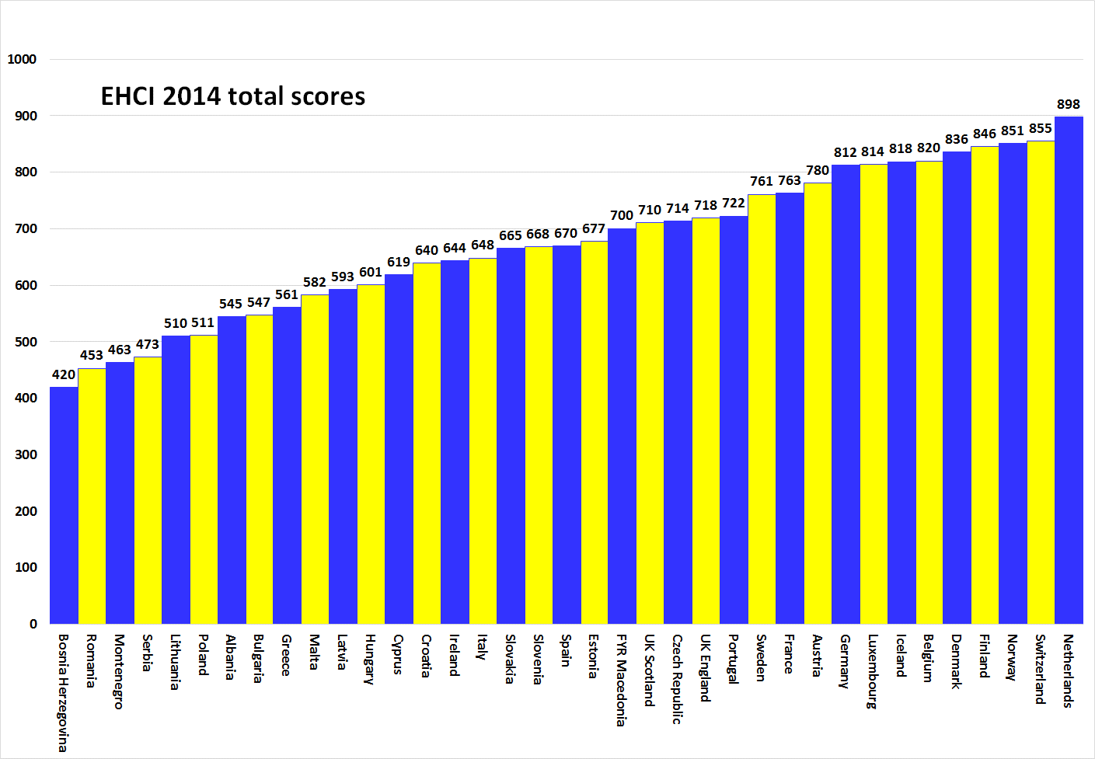

About HCP
The EHCI has become an “industry standard” of modern healthcare monitoring since the start in 2005. The Index is compiled from a combination of public statistics, patient polls and independent research conducted by Health Consumer Powerhouse Ltd, a Sweden-based private company, measuring the performance of healthcare in Europe and Canada to support patient and consumer empowerment. As the European Commission now will systematically engage in the assessment of member state health systems, EHCI sets an example.
The EHCI 2014 has been supported by unrestricted grants from Medicover S.A., Belgium, and New Direction Foundation, Belgium.
The EHCI material is published on the HCP website: www.healthpowerhouse.com . It is freely available and anybody is welcome to quote it, referring to the source.
For questions and information:
Arne Bjornberg: +46 70 584 84 51; arne.bjornberg@healthpowerhouse.com
Johan Hjertqvist: +46 70 752 18 99; johan.hjertqvist@healthpowerhouse.com

“We know the Euro Health Consumer Index (EHCI) is today the leading public measurement of how national healthcare systems perform ...We have recently learned that the European Commission after assessing various benchmarks has found the EHCI to be the most accurate and reliable comparison".
Dr. Vytenis Andriukaitis, Lithuania's Minister of Health, 2013 (since November 2014 the EU Commissioner of Health and Consumer Protection)
© HPC Ltd. 2015

