EDI 2014 General media release  2014-09-17

**European diabetes care has developed, saving 10 000 lives every year – but speedy improvement critical to meet the growth of diabetes, shows new EU comparison**

**The Euro Diabetes Index forms best practice check-list**

**(Vienna September 17, 2014) Diabetes care in Europe makes progress, as shown by a European comparison of diabetes prevention and treatment presented today during the 50th Congress of the European Association for the Study of Diabetes (EASD) in Vienna. Since 2006, the combination of healthier lifestyle, better and broader patient education, better trained physicians and improved access to treatment and devices has reduced the number of deaths in Europe due to diabetes by 10 000 a year (plus an even larger reduction of deaths from diabetes-related heart disease).**

**But as more and more people are becoming diagnosed with diabetes, diabetes care must become much more efficient. National diabetes care should move towards a pan-European best practice, the main components outlined by the study. This is the main message from the Euro Diabetes Index 2014, published today by the Sweden-based research organisation Health Consumer Powerhouse (HCP).**

**The Euro Diabetes Index outcomes in short**

The Index – a follow-up of the 2008 Euro Diabetes Index – covers the following areas, using 28 indictors: Prevention, Case finding, Range and reach of services, Access to treatment/care, Procedures and Outcomes.

The 30 countries (EU 28 plus Norway and Switzerland) are ranked according to how well they meet the indicator requirements. Sweden comes out top with 936 of a maximum 1000 points, followed by the Netherlands (922), Denmark (863), UK (812) and Switzerland (799).

The ranking of all 30 countries is in the graph below:

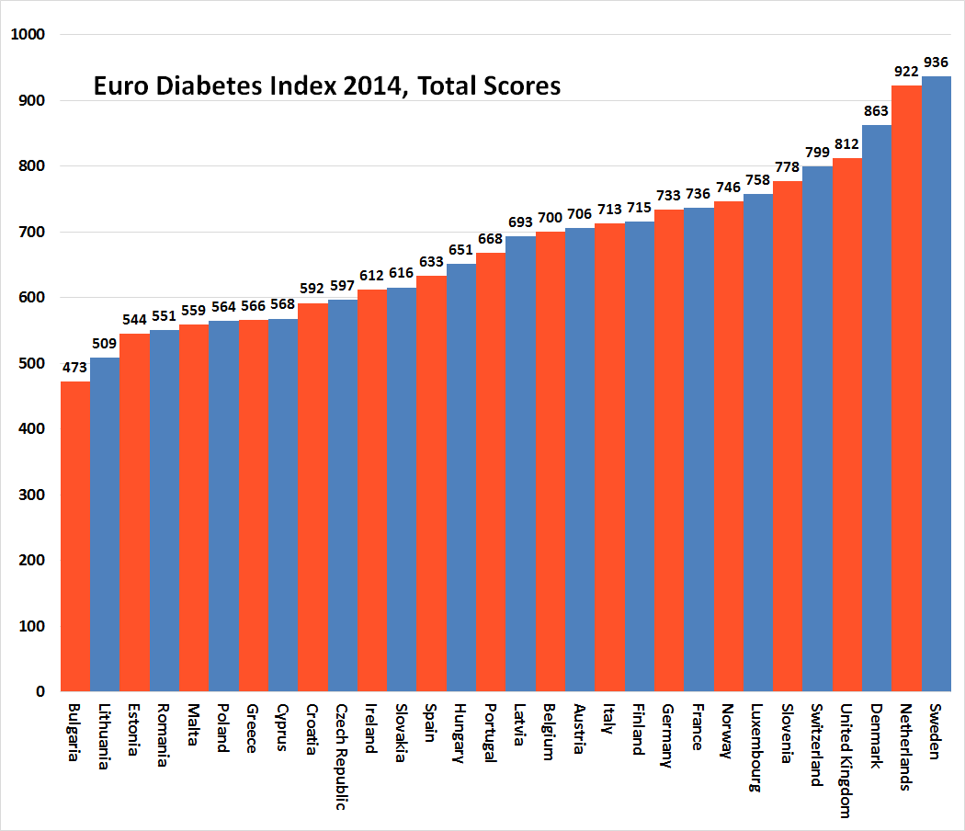

For comments on the outcomes of each country, please study the national media releases, available on [www.healthpowerhouse.com](http://www.healthpowerhouse.com)

**What are the key recommendations for improved European diabetes care?**

The 2014 Euro Diabetes Index points to pillars for a potential European best practice in diabetes prevention and care:

* **Lack of regular exercise and inappropriate nutrition should be addressed, as they cause obesity – a major diabetes type 2 risk factor**
* **National diabetes registries – exist today in no more than seven of 30 compared countries**
  + **Transparency must improve, making diabetes care data easier to access and compare**
* **Systematic screening among high-risk groups must become reality to detect undiagnosed cases – today such screening hardly exists in many countries**
* **Medication and other kinds of self-management devices must be sufficiently deployed and subsidised**
* **Structured education for patients and relatives**
* **Regular check-ups for eye, foot and renal complications.**
* **The diabetes physicians (including GPs and nurses) need to be trained to understand and adopt and new technologies, to expand their proper use.**
* Despite the burden posed by the disease, most countries have no established best practice for treatment. Since 2008, when the very first Euro Diabetes Index was published, there has been very slow increase of the number of national diabetes registries. Still, most countries cannot present data on procedures and treatment outcomes, says Dr Beatriz Cebolla, EDI director.
* Diabetes care forerunners such as Sweden, the Netherlands and Denmark have a strong fundament for screening, registration and follow up for diabetes cases, explains Dr. Bjornberg, head of HCP Index research. Fewer people fall between chairs and risk having complications. Procedures and outcomes are well documented, with reliable data. Nothing of this is rocket science but takes tedious ever-day efforts and co-operation to put in place. At the same time, it is hard to imagine how to address the diabetes growth without such best practice methodology!

**Main EDI conclusions**

The EDI recommendations above are based from the following conclusions and an analysis of the diabetes care situation around Europe as well as communication with patient groups, researchers and national health authorities.

In general, there is improvement in diabetes care compared to the inaugural Euro Diabetes Index in 2008, particularly regarding quality data acquisition and survival from diabetes complications. There are estimates saying that every year another 10 000 European diabetics survive (compared to 2006). A number of countries have started audits or annual data collection publications to increase awareness and improve outcomes. Nevertheless, there is still a long way to reach an optimal care provision and management of diabetes in Europe:

1. Still, only **seven among 30 countries report having national diabetes registries**. The lack of reliable data in indicators regarding process and outcomes is unfortunately widespread.

2. The **comparability of data collected is poor** across the EU. The indicator definitions vary enormously from country to country, often making it impossible to compare data from different countries.

3. There are important differences between sedentary lifestyles in different European countries. Physical activity varies between countries and individuals. Eating habits are also very different between countries but in general a rather low intake or non-optimal intake of vegetable and fruits and a growing consumption of soft drinks and inexpensive fast foods high in fat, salt and calories. **Lack of regular physical exercise and inappropriate nutrition is causing an increase of obesity all over Europe** – one main risk factor for Diabetes type 2.

4. Early detection and appropriate intervention presents an opportunity to improve outcomes for people with type 2. It seems there is **almost no systematic screening of high-risk groups anywhere in Europe**. Screening is frequently not uniform or systematic, even within the same country or region, but very much dependent on individual doctors’ knowledge and keenness.

5. There are a number of factors hindering optimal management of diabetes:

1. The provision of drugs and devices for proper management of the disease is essential. Surprisingly, in the past few years **a high number of countries have been reducing the provision of such essential materials**. Higher private co-payments are frequently required from patients and families to receive correct disease management.
2. Good access to continuous efficient and structured patient education, including patients’ families. However, it seems **patients receive different degrees of quality of education,** depending very much on the local professional teams.
3. Patients’ adherence to treatment is very dependent on patients understanding the procedure and importance of correct treatment. This is also related with regular contact with physicians to take decisions *together* with the patient.
4. Proper training for Doctors, nurses and other health care workers dealing with diabetes.

6. The lack of data made it hard to compare indicators regarding Procedures and Outcomes. But in general it seems there is the tendency to follow recommendations and guidelines. **More and more patients are being followed on regular basis** to monitor and prevent secondary complications than was the case in 2008.

7. Access to foot care improved in the past years. However, **a broad majority of countries still do annual foot check-ups on less than 60% of diabetics**.

8. Eye care for diabetics is far from being where it should be. The lack of data on this subject in all countries is remarkable. **A low proportion of patients get regular examinations** (every two years). The quality of those examinations is also differing.

**Diabetes background and figures**

Diabetes is one of the most critical issues facing healthcare systems across the EU, with a high burden of disease and rising prevalence. The diabetes community has been advocating for many years to make diabetes a policy priority in all European countries with some successes. These include the 2012 EU resolution calling on the EU Commission and Member States to develop and implement a targeted *EU Diabetes Strategy* and, at the end of 2013, a work package dedicated entirely to diabetes in the EU’s *Joint Action on Chronic Diseases.* These achievements make important steps forward, but more work is needed to ensure that diabetes is recognised as a key public policy priority across Europe and allocated sufficient resources to reduce the heavy burden of the illness.

• In 2013, more than 32 million Europeans live with diabetes, i.e. 8.1% of the population.

• By 2035, the population living with diabetes is expected to increase to 38 million.

• Only 50% of the population with diabetes have been diagnosed.

• Over 50% of adults with diabetes fail to reach the levels of blood sugar required.

• In 2013, Europe spent approximately €100-150bn on treating and caring for diabetes.

• Diabetes is a major cause of kidney failure, blindness, foot and leg amputation and heart disease.

• One in ten deaths in Europe can be attributed to diabetes – equaling 619 000 deaths in 2013.

• Europe is home to the highest number of children with type 1 diabetes in the world.

• Europe has the highest incidence rate for new cases of type 1 diabetes in children.

• There is growing evidence that type 2 diabetes in children and adolescents is increasing.

• Young people with type 2 diabetes risk developing complications earlier in life, with devastating consequences for their families and society.

• Currently, reliable data on the true costs of caring for people living with diabetes is scarce. The issue of having accurate and timely data on diabetes medicines and medical devices thus needs to addressed, as currently decisions are being made in the absence of such information.

• A rise in diabetes and diabetes-related complications will put a severe strain on healthcare systems which currently spend on average an estimated 10% of their budget on diabetes care. In some countries, this figure is as high as 20%.

• IDF Europe is an umbrella organization representing 69 diabetes organisations in 47 countries across Europe. It is the European chapter of the International Diabetes Federation

**Who produced the Index and how was it developed?**

Health Consumer Powerhouse (HCP) has developed the comparative index ranking of 28 EU Member States (plus Norway and Switzerland) first published in 2008, according to country performance with regard to type 1 and 2-diabetes over the course of 2014.

HCP, the leading European provider of consumer information on health care, worked with experts from across Europe and the different fields of diabetes to develop a number of indicators for assessing diabetes care. 28 indicators from a long list of indicators were scored in a systematic manner to reflect and compare the healthcare situation in the different EU countries (plus Norway and Switzerland), from perspectives ranging from prevention policies to access to treatment, the management of the disease and patient outcomes.

The indicators were organised into the following categories:

• Prevention

• Case finding

• Range and reach of services (“Generosity of care”)

• Access to Treatment/Care

• Procedures

• Outcomes

Once the indicators were defined, HCP gathered information from a variety of sources including existing data, country visits with experts and face-to-face interviews. To be used as a feed-back information, an e-questionnaire was designed to collect responses from patient organisations representatives and other relevant stakeholders. One benefit of collecting data in this fashion is that it opens and fosters a dialogue with key stakeholders. All contributors and responsible authorities in each country were given the opportunity to review their own preliminary results before publication of the Index.

The full Index presentation, with the report, matrix and individual media releases for 30 countries, is available for free at [www.healthpowerhouse.com](http://www.healthpowerhouse.com). Please quote the source when using the material. The EDI will also be presented at an open webinar September 17, 09:00 – 11:00, <http://bambuser.com/channel/healthpowerhouse>

The 2014 Euro Diabetes Index has received an unrestricted grant from MSD.

For questions about the Index:

Dr. Arne Bjornberg, mobile phone: +46 705 848451, [arne.bjornberg@healthpowerhouse.com](mailto:arne.bjornberg@healthpowerhouse.com)

Dr. Beatriz Cebolla, +49 152 2371 9856, [beatriz.cebolla@healthpowerhouse.com](mailto:beatriz.cebolla@healthpowerhouse.com)

For more information about the 2014 Euro Diabetes Index and the Health Consumer Powerhouse, please visit [www.healthpowerhouse.com](http://www.healthpowerhouse.com) or contact us at [info@healthpowerhouse.com](mailto:info@healthpowerhouse.com). You can follow us on Facebook and Twitter: @HCPhealthindex

© HCP Ltd. 2014